**COEN 275**

**Final Project**

**CampusSmartCafe**

README

COEN 275

Authors:

Naina Raut W1186663

Mani Bhargavi Ketha W1186016

Course Number: 36292

Due Date: June 7,2016

**Environment**: Eclipse IDE for Java Developers

Version: Luna Service Release 2 (4.4.2)

Oracle Database 11g Express Edition

**Introduction:**

This project is simulation of a Campus Smart Cafe machine wherein each student and faculty member is given a smart card to provide access various facilities provided by the machine. The facilities include:

* Order meals from campus cafes,
* Buy food from vending machines on campus
* Set the available funds for the particular month
* Set calorie requirement for the day
* Set allergy restrictions if any.
* View daily and yearly calorie statistics
* View daily and yearly funds statistics

The project utilized a relational database for persistence. The Oracle Database Express Edition was used to organize and store the data for the Java Application. Data was inserted into tables through the use of JSON files which were then parsed by in the java application to insert into the appropriate tables.

Food Table

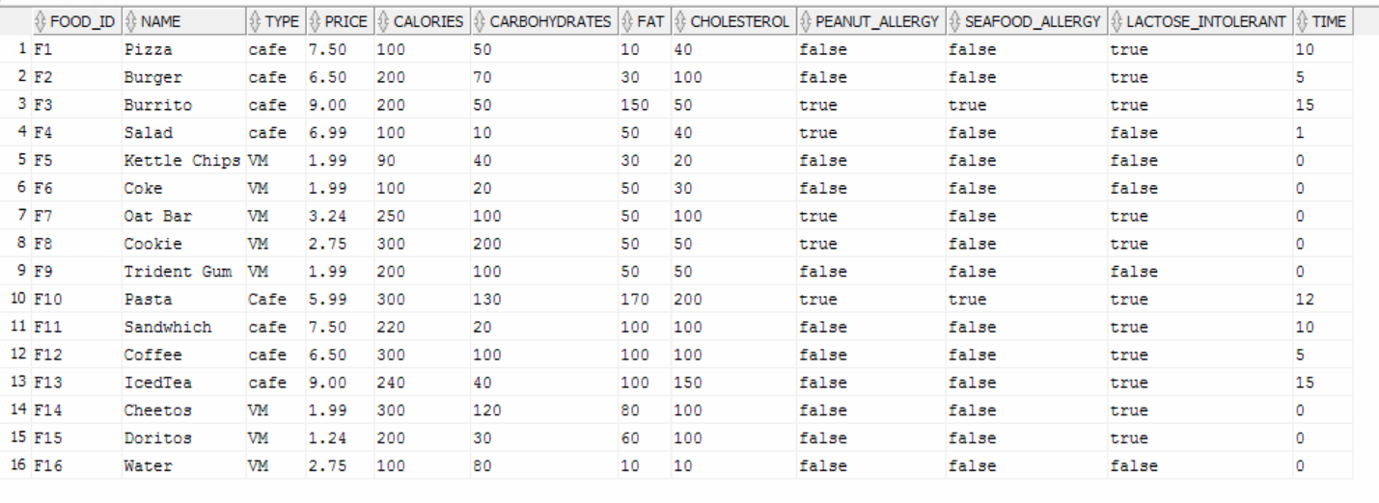CampusCafe Table

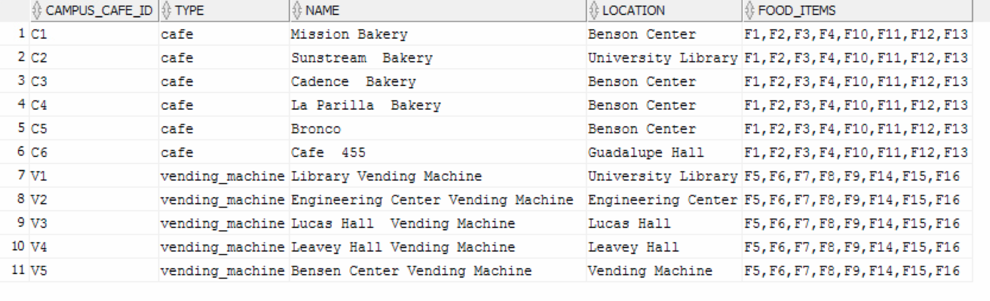

User_details Table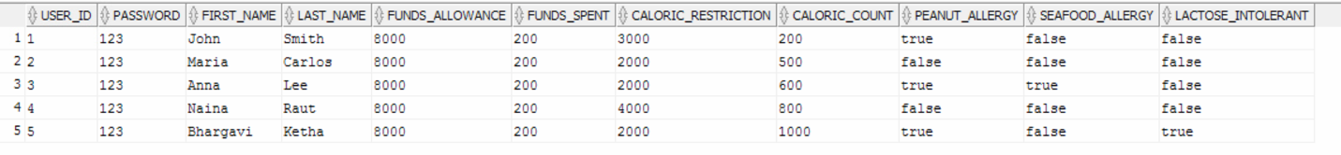

Order_details table: Used to store information about orders. 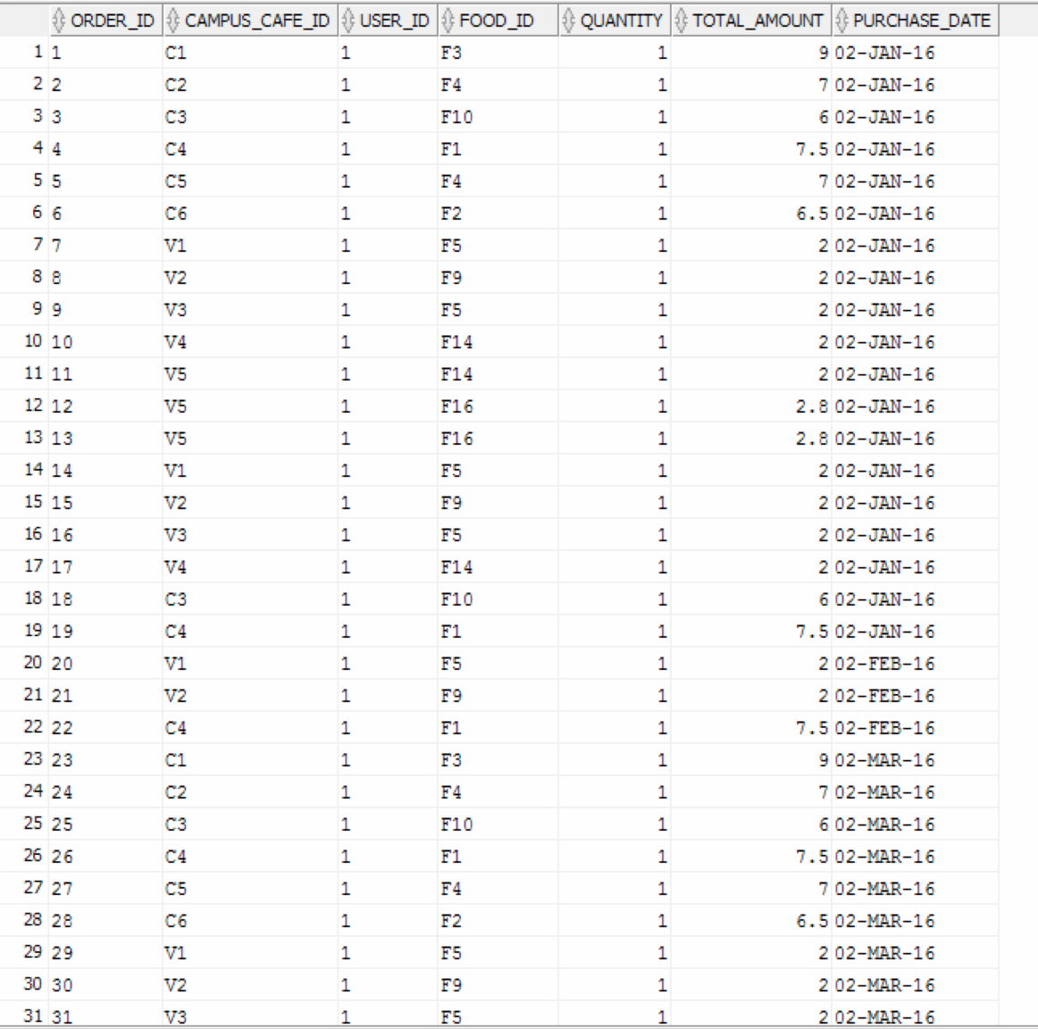

***Note:***

**Database Setup:**

In order to run the application, the database must be set up and connected to the application through the databaseconnectivity class. This includes adding jdbc and odbc jar files. Before this step, the database must be set up by running the created.sql file to create required tables and sequences. Then the insertdata.java file must be run to insert data from the json files provided (food.json,order_details.json,campus_cafe.json and user_details.json). We must add the org.json jar files in order to be able to parse the json files. Now the database has been set up and ready to use for the campuscafe java application.

**Testing the Application:**

In order to test the application, the jdbc and odbc external jar files must be imported. The entry point for the application is the mainframe.java file which will launch into the login page. The details for a user which can be tested upon are given below;

UserId: 1

Password: 123

Through the screenshots the user can now traverse through the application and be able to view the various functionalities such as placing orders, updating their profile and viewing statistical charts.

The user can login using his user id and password. Invalid user id and password will display

An error message to the user.

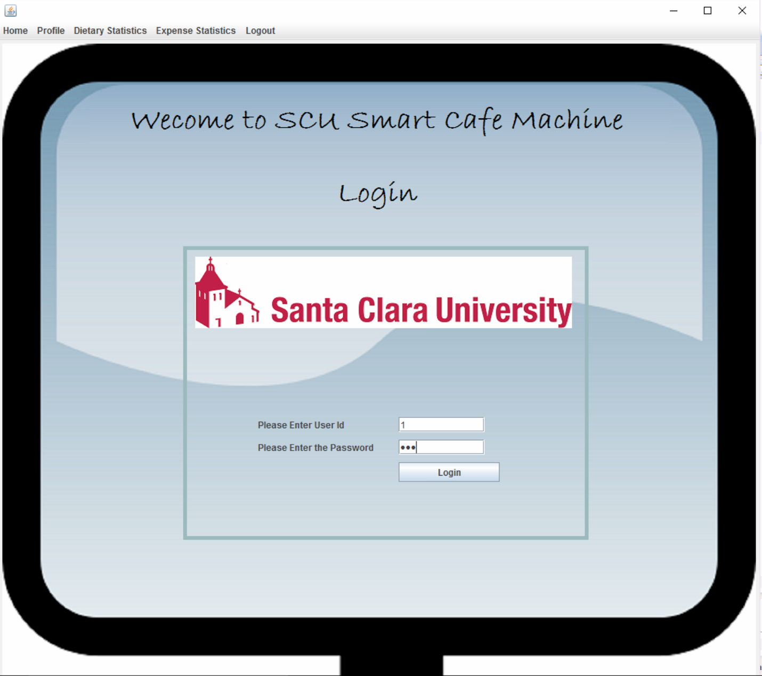

The user can view his profile from the profile tab in the menu bar. In the profile page the user can set his available funds for the month, calorie requirement for the day and can select any allergies from the specified options.

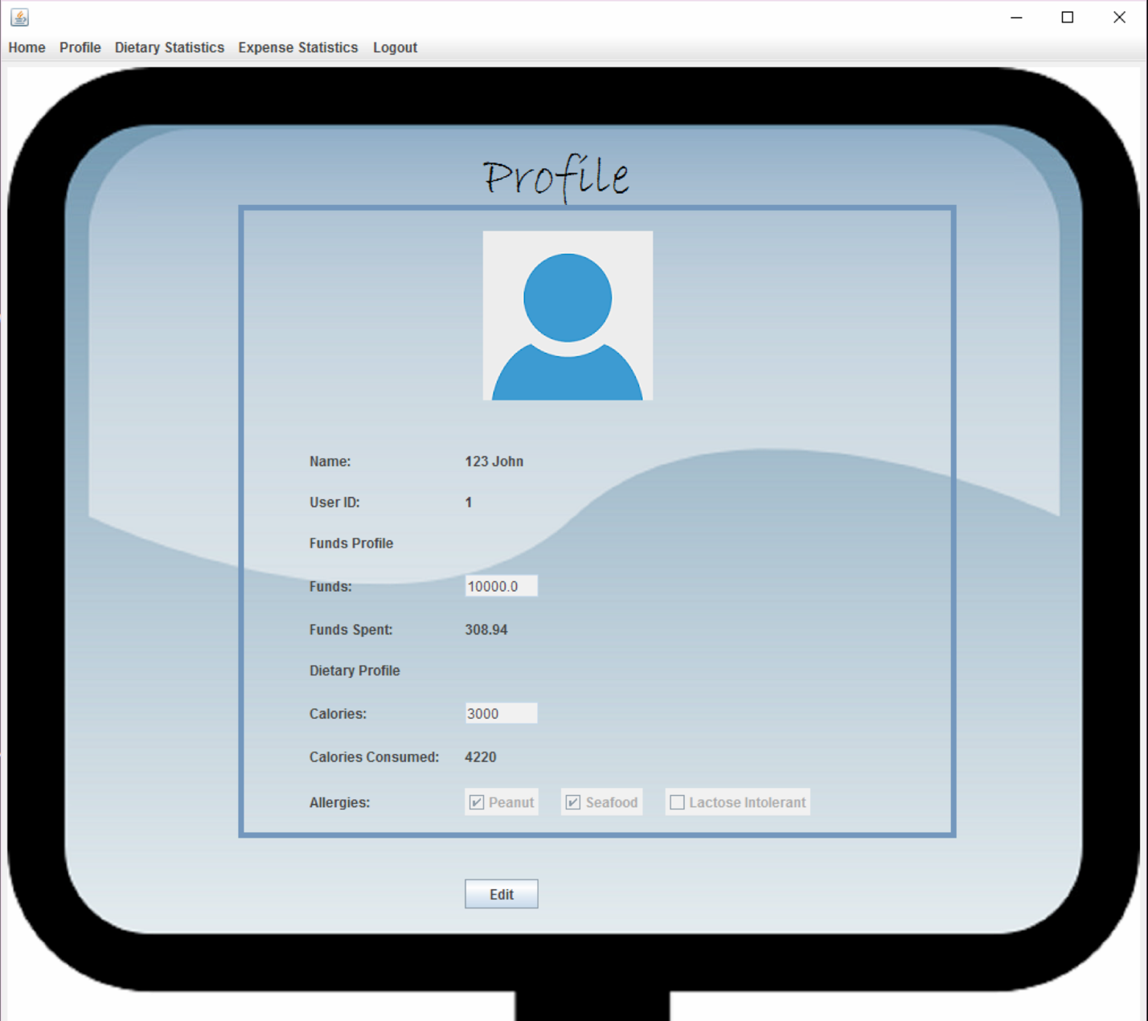

After login the user can see the campus map with the icons of campus cafes and vending machines. On mouse hover you will be able to see the name of the venue.

The user can select any café or vending machine from which he wants to buy food.

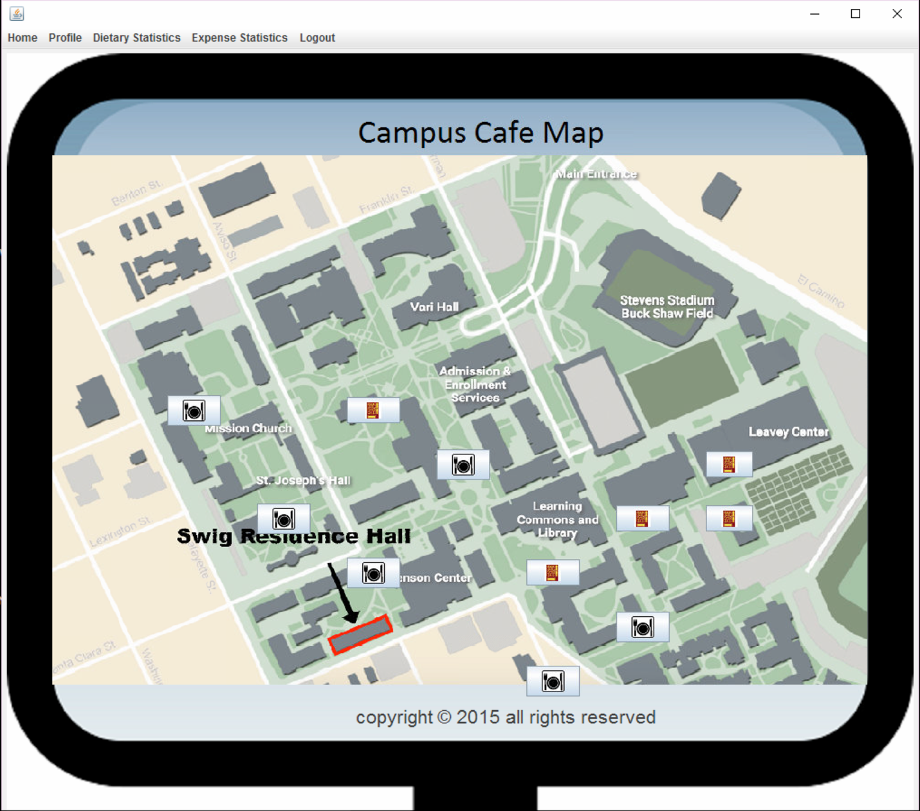

After selecting a venue from the campus map, the user will be directed to the menu page. This page displays the menu with all the food items available in the selected café or vending machine.

The user can select multiple food items by checking the checkbox beside the item and can click on checkout.

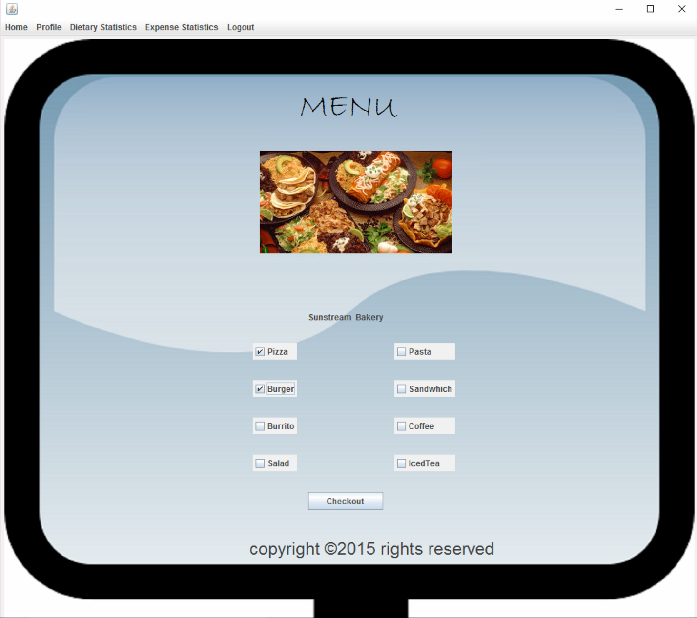

After the user clicks on checkout, he will be directed to the cart page where he will see all his selected food items. Here he can enter the quantity for the selected food items.

The user can also see the calories contained in the food item with all the fats, cholesterol and carbohydrates.

The user has the option to remove any selected food item by using the remove button.

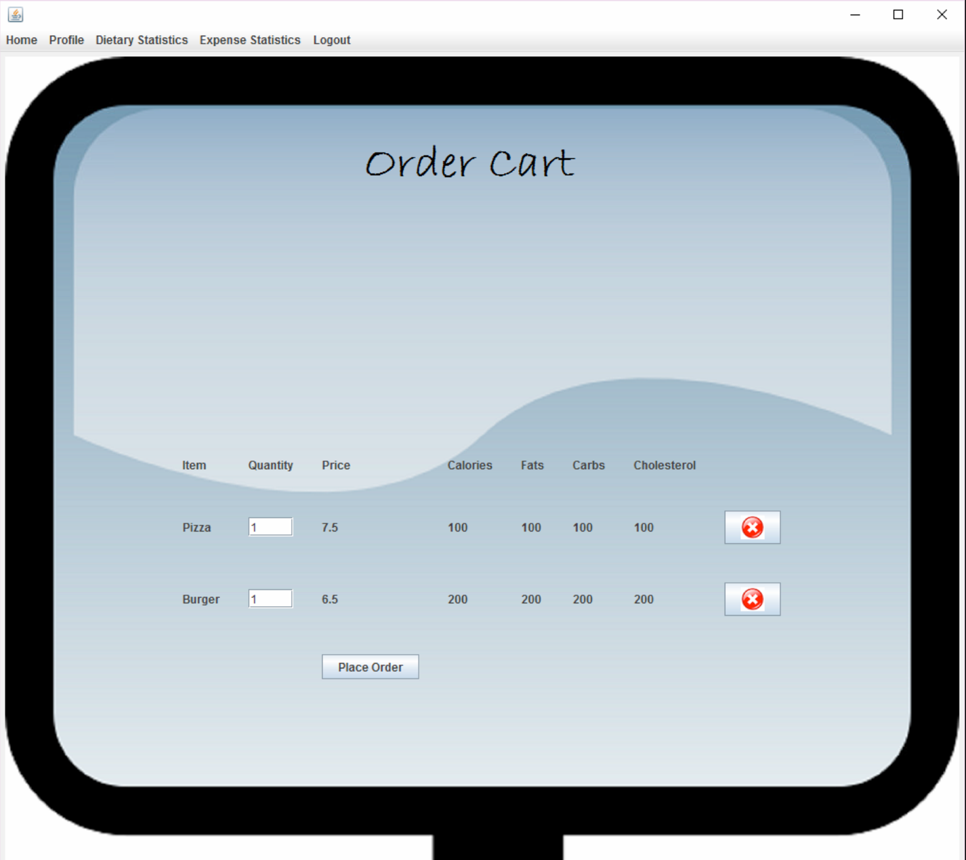

If the available balance is less than the ordered food items amount, then the user will get an error message saying insufficient funds and will remain on the same page.

If the required calories exceed the consumed calories after the selected food items, or if any of the selected food items consists of allergic food specified in the user profile, then the user will get a warning message.

And if the user has sufficient balance then his order will be placed successfully and he will be directed to the order receipt page where he can see all his ordered food items.

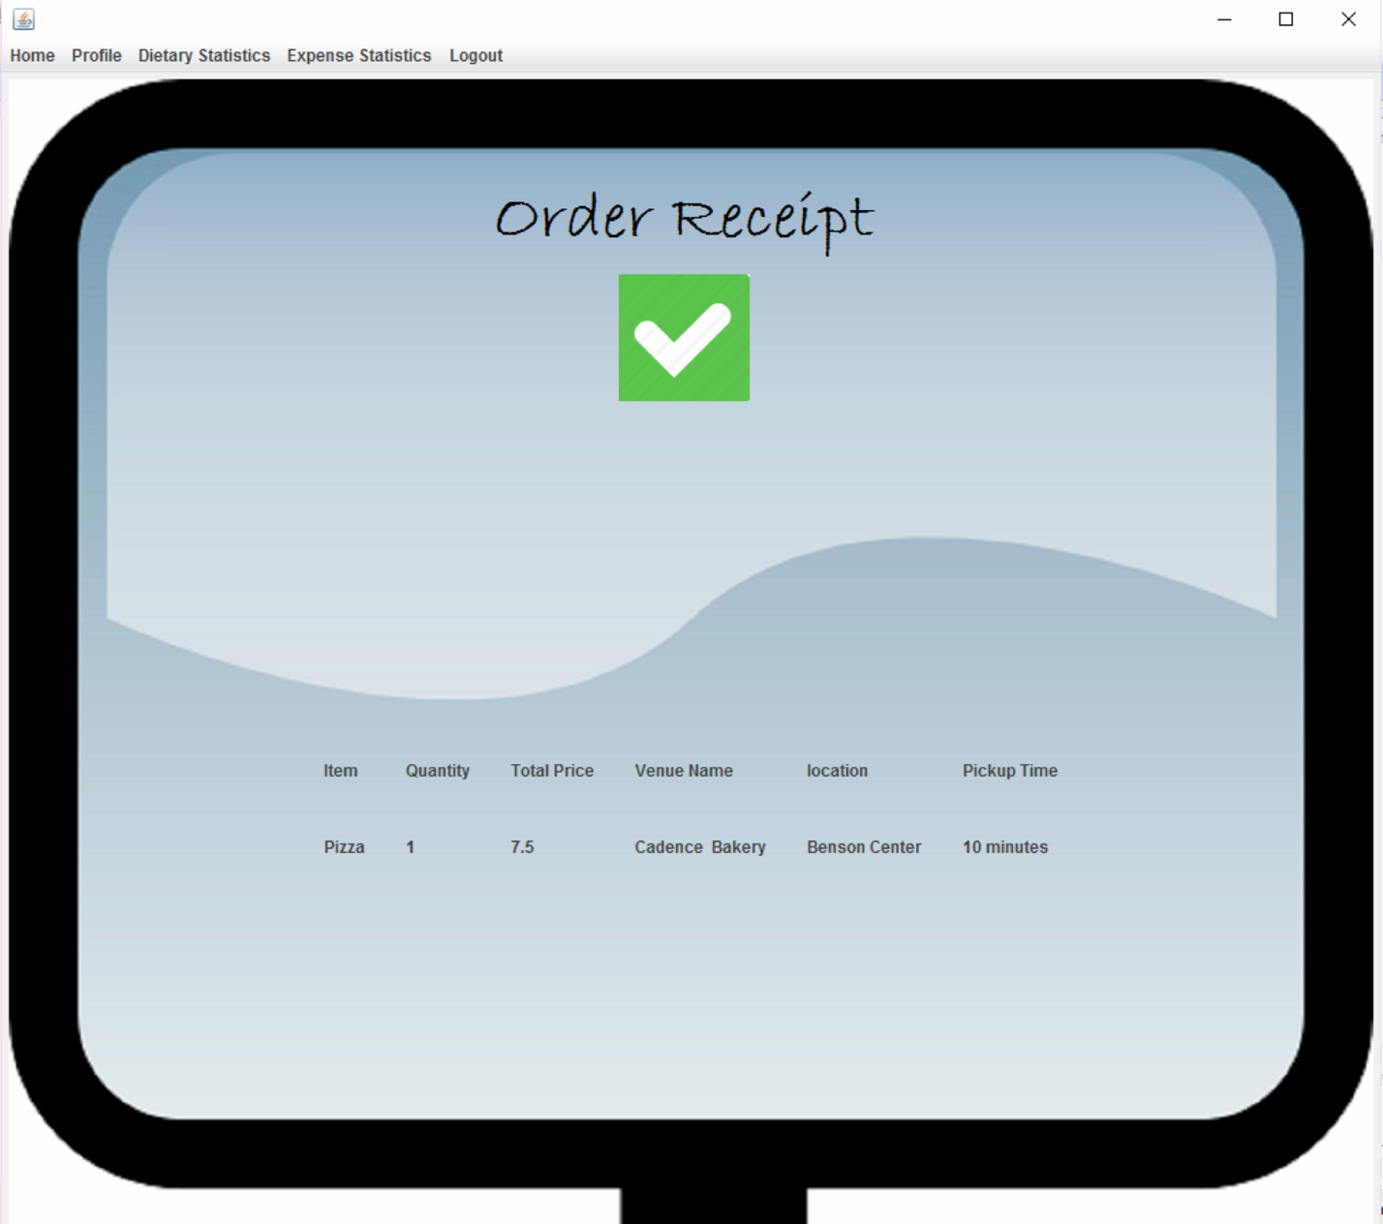

The user can see the pickup time for the food only if he has selected the campus café.

The user can view the funds spent by him over the year by selecting the ‘Yearly Expense Statistics’ from the Expense Statistics in the menu bar. Each bar defines the funds spent by the user in dollars in that month.

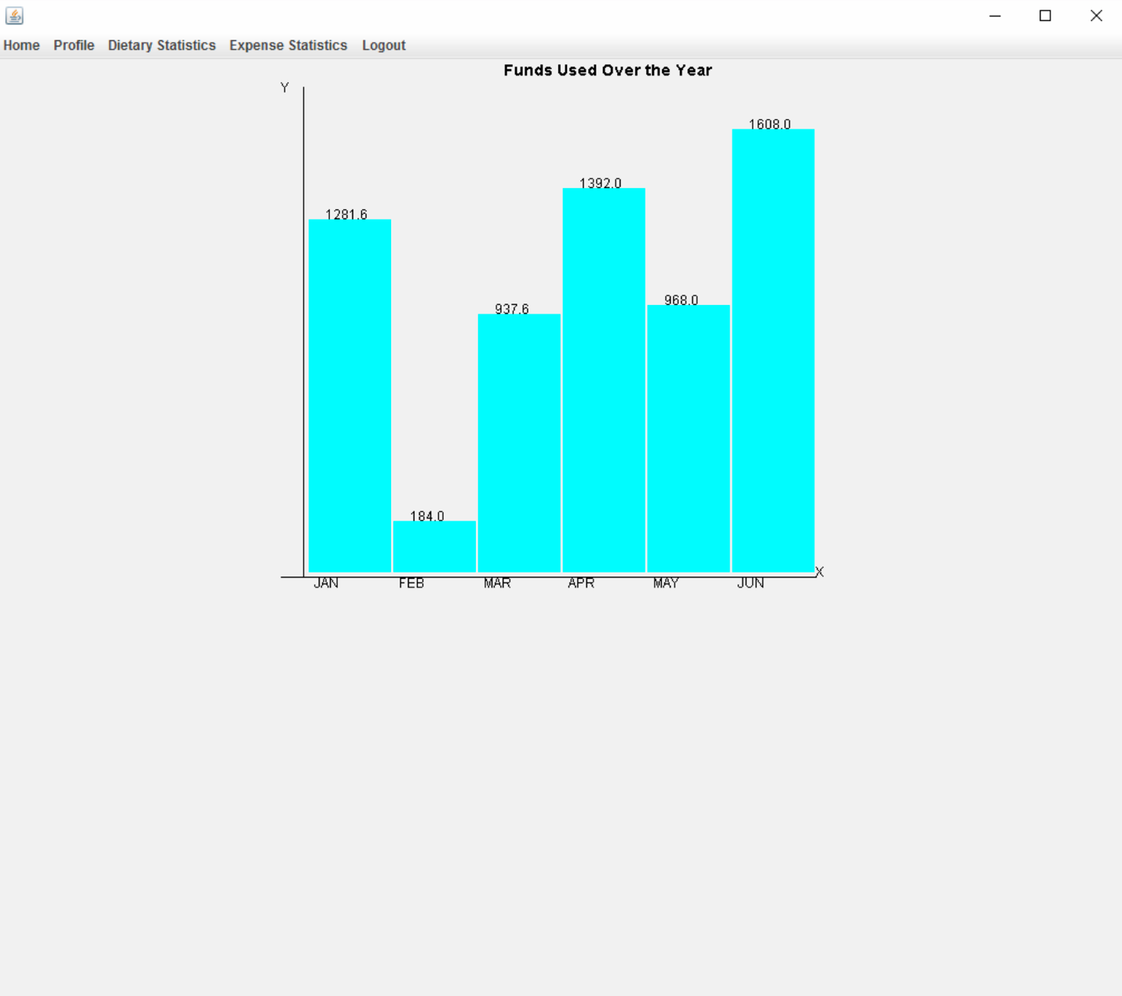

The user can view his funds spent daily from the ‘Daily Expense Statistics’ in Expense Statistics option in the menu bar.

The blue portion specifies the funds used and the red portion specifies the funds available.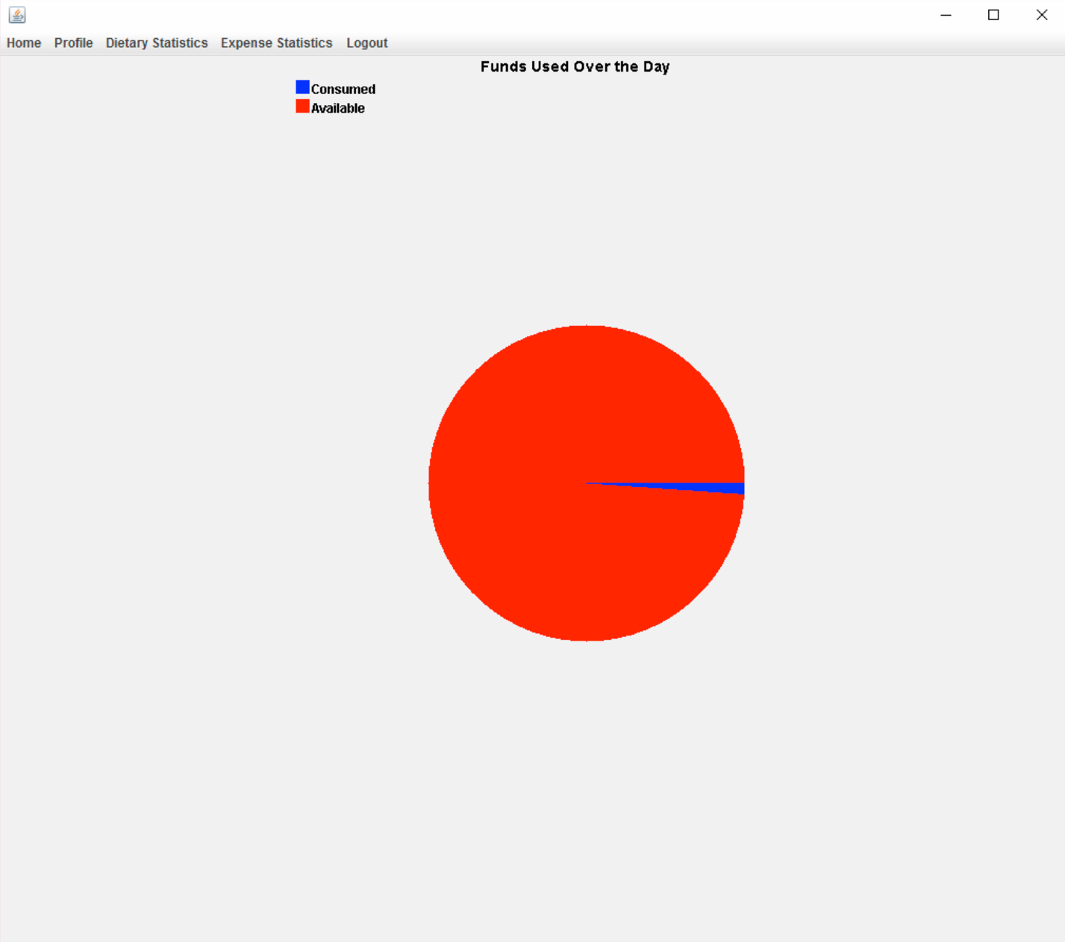

The user can view the calories consumed by him over the year by selecting the ‘Yearly Dietary Statistics’ from the Dietary Statistics in the menu bar. Each bar defines the calories consumed by the campus card user in calories in that month . 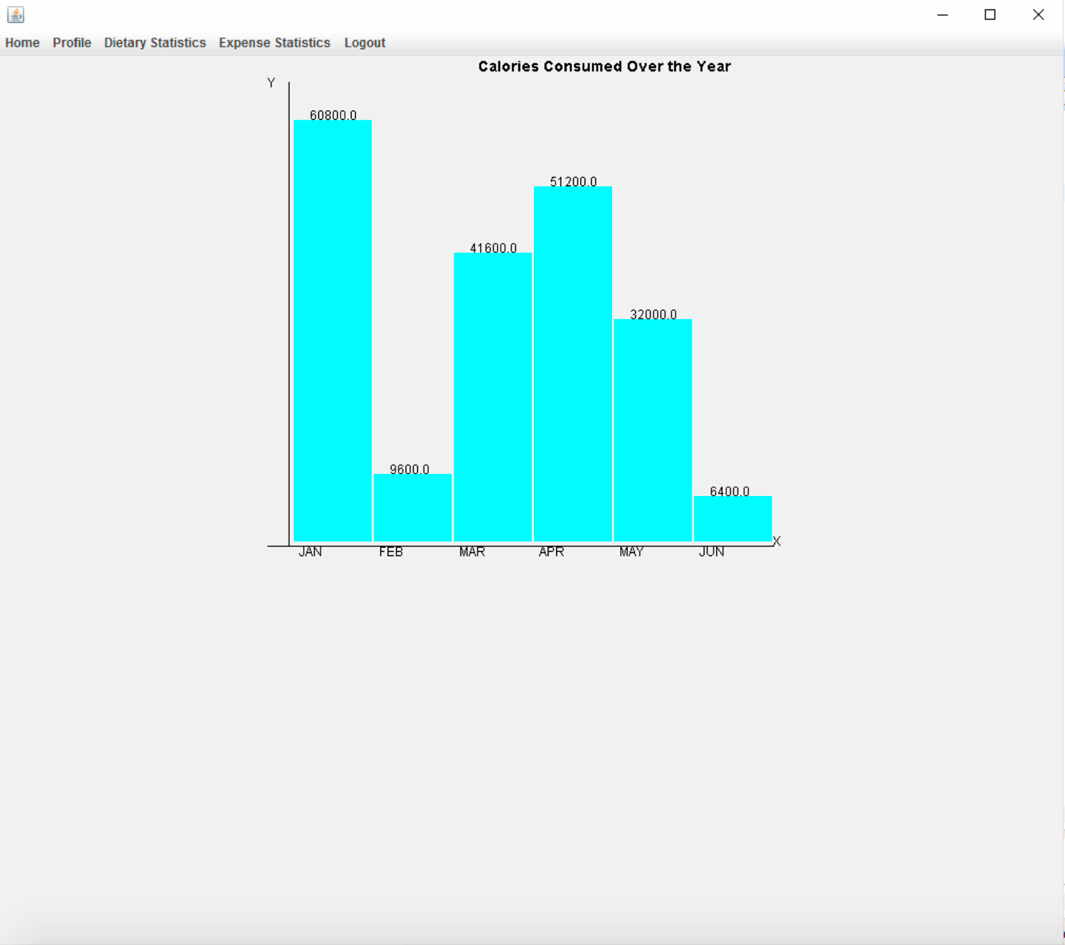

The user can view his funds spent daily from the ‘Daily Expense Statistics’ in Expense Statistics option in the menu bar.

The blue portion specifies the funds used and the red portion specifies the funds available.

